- TITLE
Lot-to-Lot Validation of Rapid Tests

- PURPOSE
The purpose of this procedure is to provide guidance on how to perform lot-to-lot validation for HIV rapid tests kits.

- SCOPE
This procedure enables performing lot-to-lot validation for HIV rapid test kits using a dilution panel.

- EQUIPMENT
  - Bio-safety cabinet (BSC)
  - Pipette aide
  - Pipette (1000 µl)
  - Centrifuge
  - Tube racks

- SUPPLIES
  - Freezer boxes
  - Storage bottles
  - Gloves
  - Lab coat
  - Table diaper
  - Decon Iradecon Bleach-Based Disinfectant
  - Biohazard bags
  - Biohazard containers
  - HIV rapid test kits
  - HIV Lot-to-Lot Validation panels
  - 2.0 mL conical bottom Sarstedt cryo-tubes
  - Pipette tips
  - Pipette, 10 mL
  - 15 mL conical tubes
  - Freezer boxes
  - Tube racks
  - Cryo labels
  - 50 ml conical tubes
  - Labels
  - Gloves
  - Lab coat

- SPECIAL SAFETY PRECAUTIONS
  - Wear personal protective equipment, including gloves, when in contact with blood, bodily fluids, secretions, excretions, mucous membranes and contaminated items.
  - Wash hands immediately after removing gloves.
  - Clean up spills of infective material promptly with Decon Iradecon Bleach-Based Disinfectant (ready to use).
  - Ensure that equipment, supplies and linen contaminated with infective material is either discarded or disinfected or sterilized between care of study participants.
  - Follow the national protocol for post-exposure prophylaxis (PEP), in the event of a sharps injury.

- PROCEDURE
  - Verify each new lot of the HIV rapid test kits:
    - Set gold standard results:
      - Three different operators should perform testing on all HIV rapid tests used in the testing algorithm.
      - Use the 2 out of 3 results in agreement for final result for a particular specimen.
  - Perform lot-to-lot comparisons by comparing previously tested samples or the lot-to-lot panel (see Tables 1-3 and pictures). Lot-to-lot comparisons should be done:
    - With each new kit lot or lot change.
    - With each new shipment of kits.
    - When temperatures exceed the manufacturer recommended storage conditions.
  - Panel stability and quantity
    - The lot-to-lot panel should be stored at -20°C or below for long-term storage, but once a set has been thawed, it should be kept at 4°C for up to 7 days.
    - Label the thawed specimens with date removed from storage, expiration date and the name of the laboratory scientist who thawed the specimens. A maximum of 5 freeze and thaw cycles are permitted.
    - Exercise care in opening and removing aliquots from vials to avoid microbial contamination.
    - There are 20 lot-to-lot panels with 400 µL/tube stored at -20°C available at the start of the study which are presented in the following table.
Table 1. HIV Dilution Panel Example
Original ID | Dilution factor | Specimen ID | HIV Rapid Test 1  Determine HIV 1/2 | HIV Rapid Test 2  Uni-Gold HIV 1/2
Lot: |  |  | 83142K100 | HIV7060032
Expiry: |  |  | 2018-11-12 | January 24, 2018
Date Tested: |  |  | April 16, 2018 | April 16, 2018
HIV Pool #1 | 0 | Lot-to-Lot 1 | +++ | ++
 | 5 | Lot-to-Lot 2 | ++ | +/-
 | 25 | Lot-to-Lot 3 | + | -
Diluent | 125 | Lot-to-Lot 4 | +/- | -
Neg Pool #1 | 625 | Lot-to-Lot 5 | - | -
 | 3125 | Lot-to-Lot 6 | - | -
 | 15625 | Lot-to-Lot 7 | - | -
 | 78125 | Lot-to-Lot 8 | - | -
 | 390625 | Lot-to-Lot 9 | - | -
 | 1953125 | Lot-to-Lot 10 | - | -
HIV Pool #2 | 0 | Lot-to-Lot 11 | +++ | ++
 | 5 | Lot-to-Lot 12 | ++ | +
Diluent | 25 | Lot-to-Lot 13 | + | +/-
Neg Pool #1 | 125 | Lot-to-Lot 14 | +/- | -
 | 625 | Lot-to-Lot 15 | - | -
 | 3125 | Lot-to-Lot 16 | - | -
 | 15625 | Lot-to-Lot 17 | - | -
 | 78125 | Lot-to-Lot 18 | - | -
 | 390625 | Lot-to-Lot 19 | - | -
 | 1953125 | Lot-to-Lot 20 | - | -

Determine

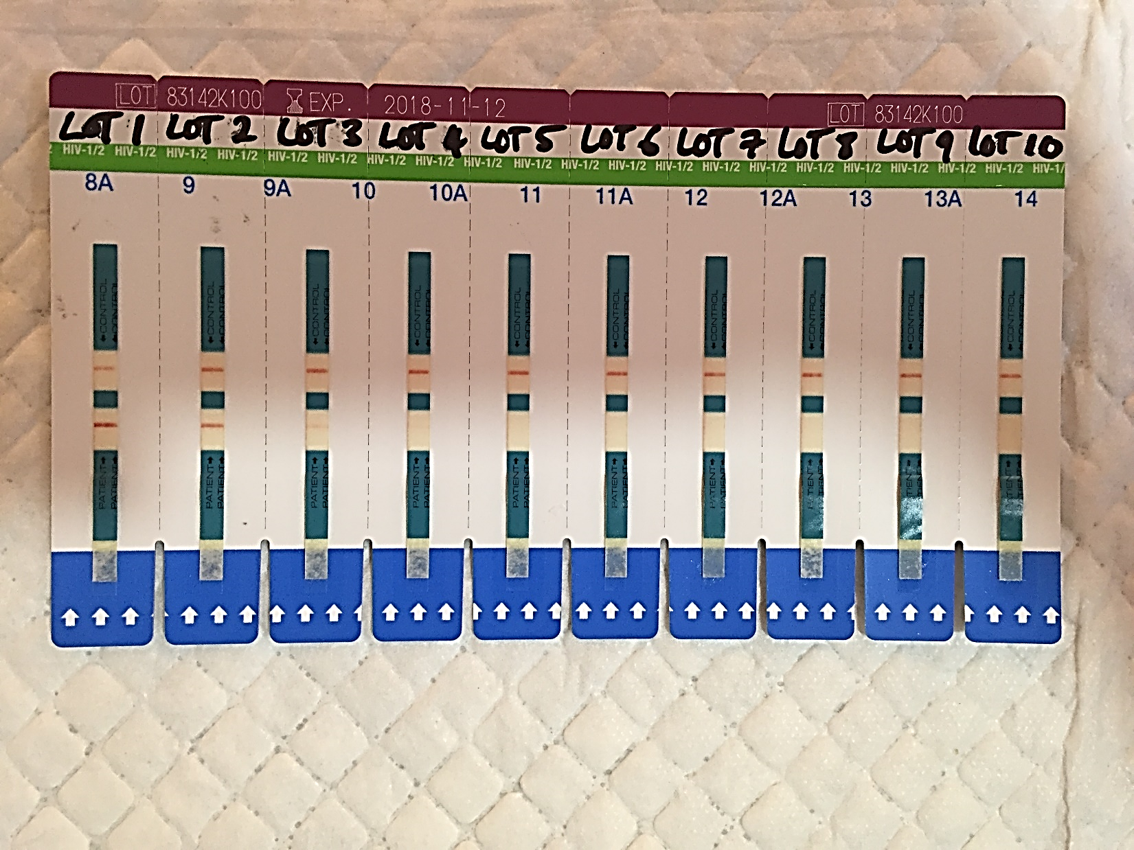

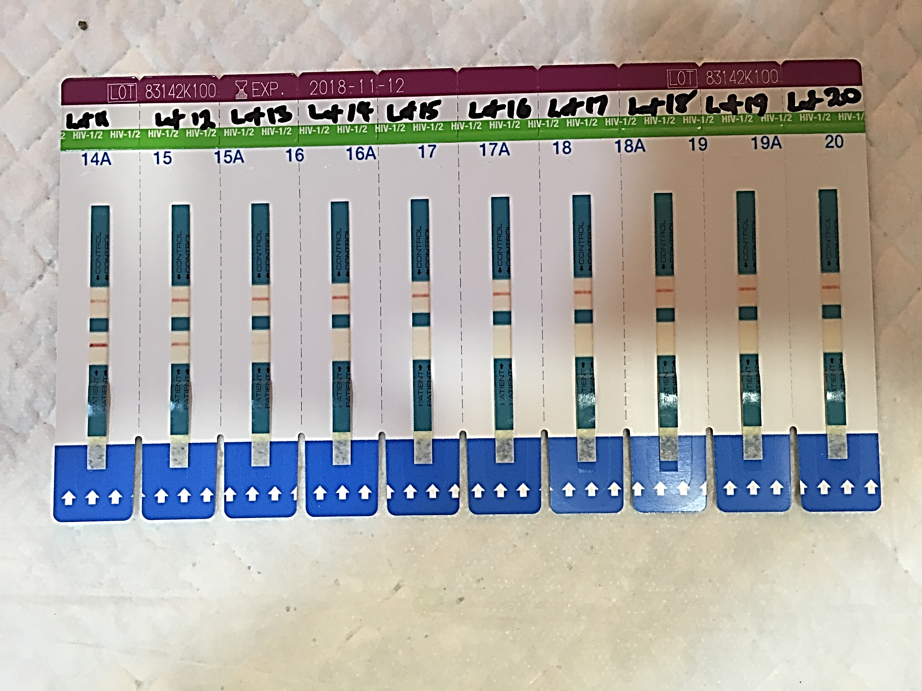

Stak Pak

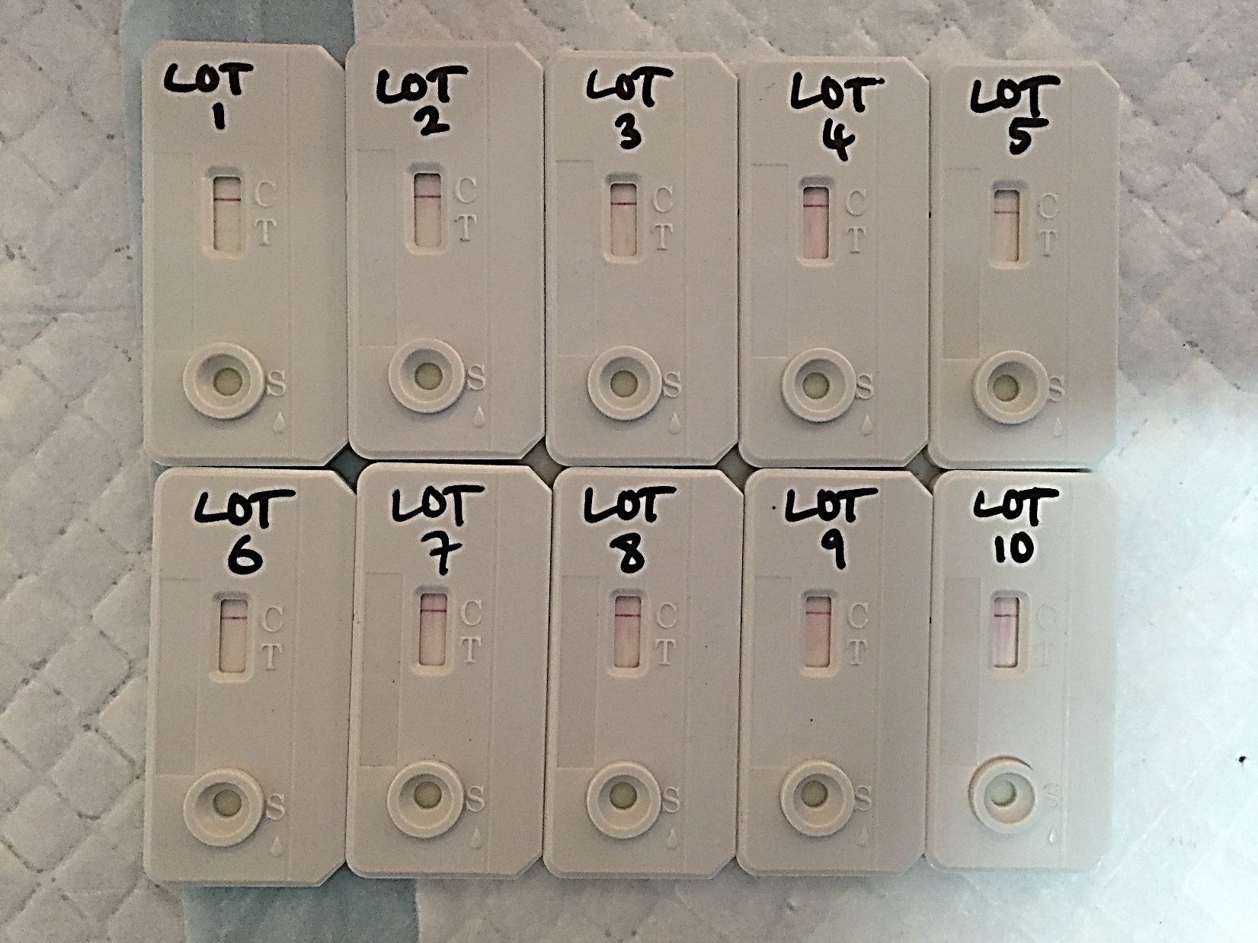
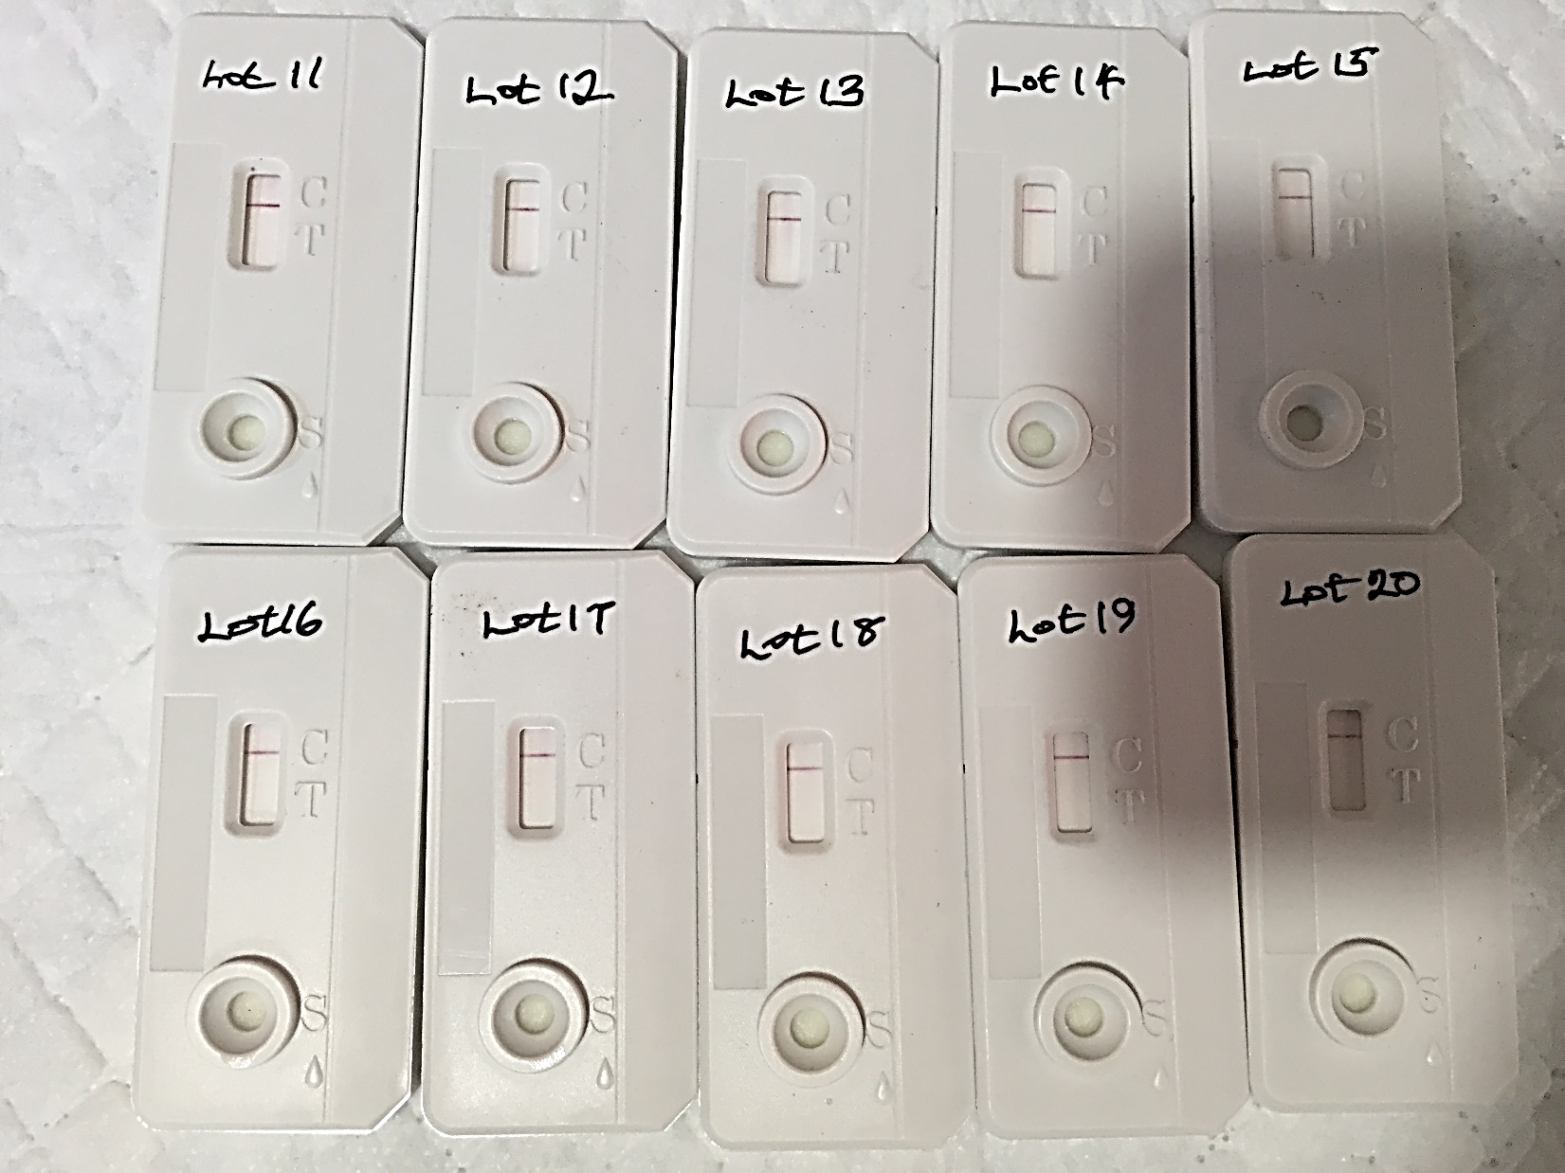

  - Panel Preparation Procedure:
    - Obtain rejected whole blood or plasma units from local blood bank of different HIV reactivity, including some HIV negatives.
    - When using whole blood units, transfer whole blood from bag to clean 50 mL conical tubes, centrifuge at 1000-1300 RCF for 10 minutes to separate plasma.
    - Transfer plasma from the bag to a clean storage bottle. Store plasma at 4°C until further testing has been conducted.
    - Regardless of status given by the blood bank, the specimen reactivity should be verified by the laboratory that is responsible for preparing the panel.
    - Plasma specimens should be characterized with respect to their HIV status by all HIV rapid tests, ELISA, and Western blot (if available) based on country-specific algorithm.
  - Preparation of lot to lot validation panel
    - Identify and select 2 HIV positive samples for preparing separate serial dilutions. Use only those samples that have been identified as positive or reactive by all testing methods based on the country testing algorithm from the samples collected, tested and stored properly from the specimen bank.
    - Identify and select negative samples that have been tested by all tests or base matrix (can be purchased commercially), if available. Make sure that samples are clear of any clots or fibroids.
    - Calculate the amount of negative serum/plasma required or base matrix for preparing 1 dilution set 10 times with 5 fold dilution factor. (See table below). Follow the same procedure for set #2.

Set No. | Original Specimen ID | Dilution ID | Dilution Level | Positive  Specimen (mL) | Base Matrix or Negative Serum (mL) | Dilution Factor
 |  |  | i | 8 | 0 | Neat
 |  |  | ii | 2 mL | 8 | 5
 |  |  | iii | 2 mL of ii | 8 | 25
 |  |  | iv | 2 mL of iii | 8 | 125
1 |  |  | v | 2 mL of iv | 8 | 625
 |  |  | vi | 2 mL of v | 8 | 3125
 |  |  | vii | 2 mL of vi | 8 | 15625
 |  |  | viii | 2 mL of vii | 8 | 78125
 |  |  | ix | 2 mL of viii | 8 | 390625
 |  |  | x | 2 mL of ix | 8 | 1953125

    - Dilution can be prepared in 15 mL conical tubes.
    - Once dilutions are prepared, treat each dilution as an individual sample and carefully make 400 µL aliquots in pre-labelled Sarstedt tubes.
    - Transfer the aliquots into a cryo boxes and store at -20°C or below until use.
    - Once the dilutions are prepared and aliquoted, remove a working set of samples for establishing reference results.
    - Test all 20 samples prepared for the HIV dilution panel on all HIV 1/2 rapid tests and record results.
    - Use the panel for lot to lot validation

  - INTERPRETATION/RESULTS
    - Use the Lot-to-Lot Validation Form to record the results.
    - Adhere to the results acceptance criteria:
    - Compare results of the new lot with results of the gold standard.
    - The kit lot should be approved if a variation of ±1 dilution factor is observed.
    - The kit lot fails if greater than ±1 dilution factor is observed.t
    - The verification form should be signed and dated by the supervisor for approval.
    - Once the validation is approved, the Laboratory Scientist should place a sticker that indicates that the kits are ready to use.

